Acoustic Monitoring Manual for Tidal Marsh Environments
Version 2.0 - June 18, 2025
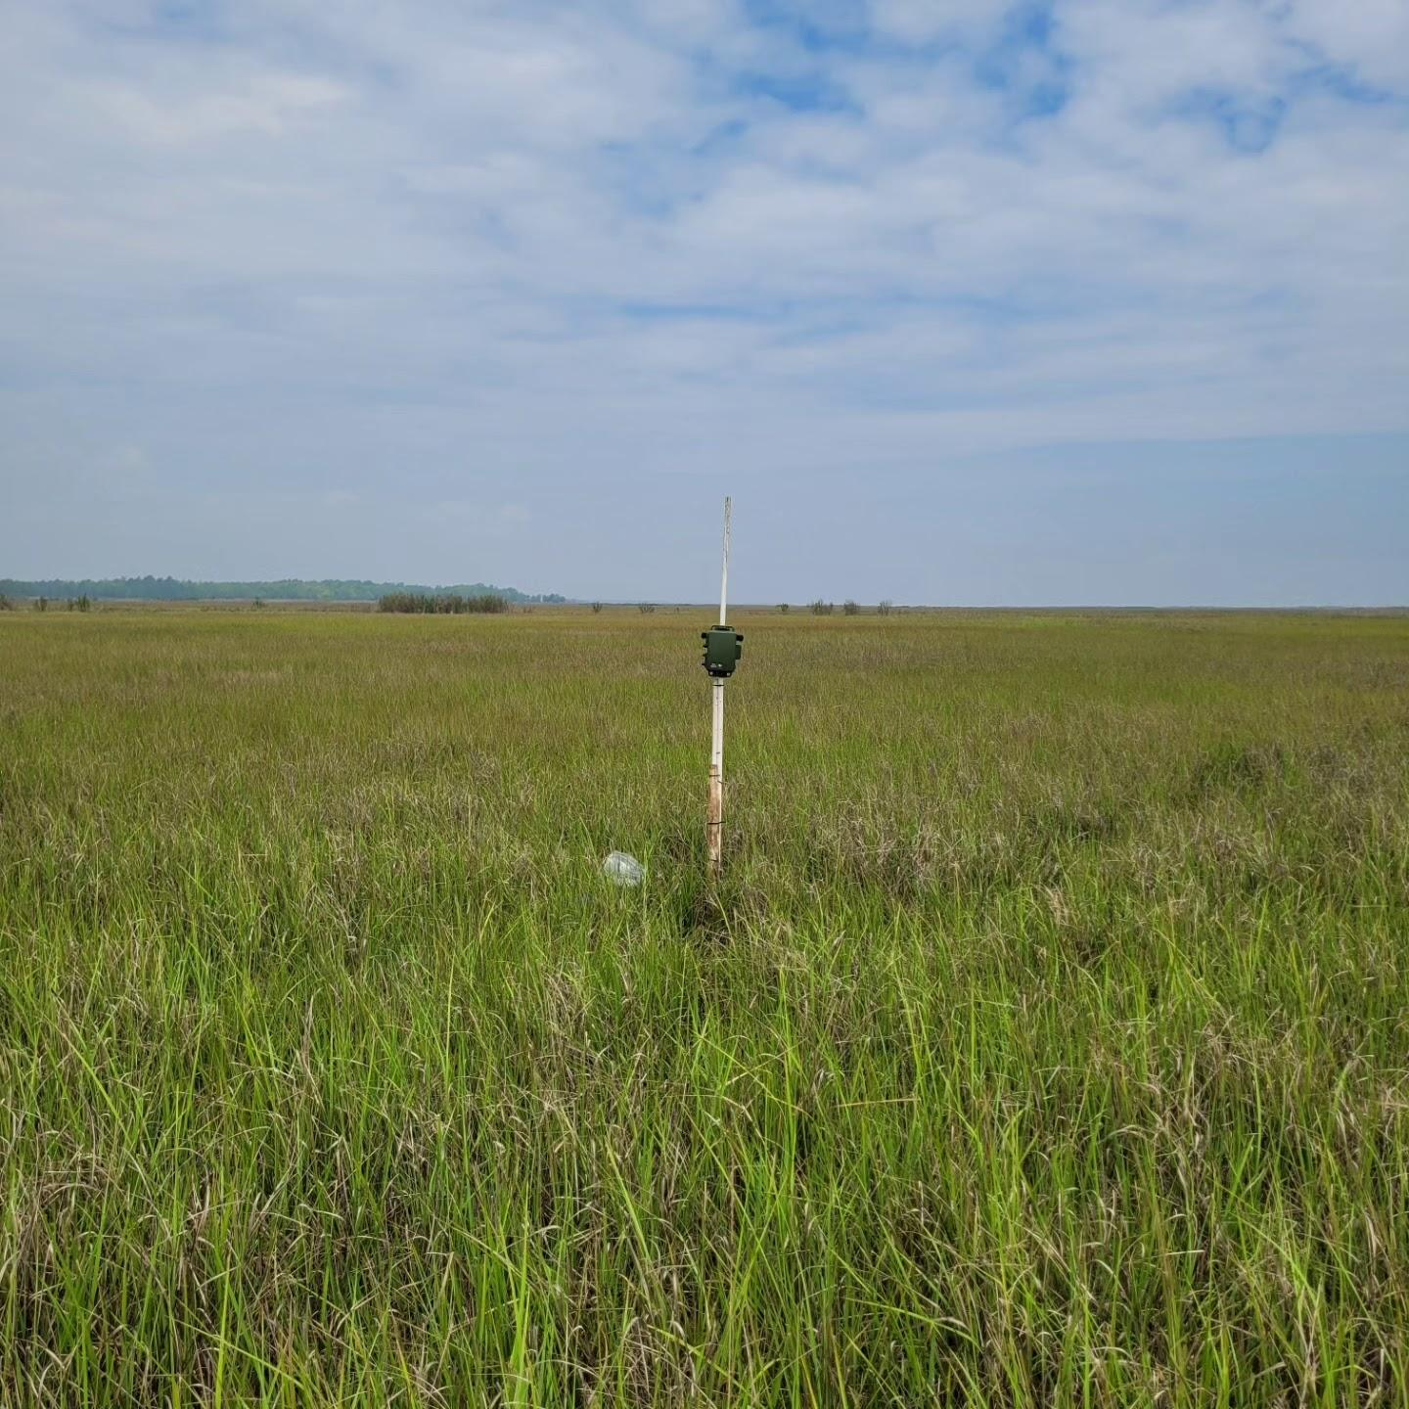
Photo Credit: Kelly Faller
Prepared by:
Kelly Faller, Graduate Student
Rutgers University
Suggested Citation:
Faller, K. (2025). Acoustic Monitoring Manual: Deployment, Maintenance, and Data Management for Tidal Marsh Environments. Version 2.0. https://doi.org/10.5281/zenodo.15692883.
Available at: https://github.com/KellyFaller/Coastal-Marsh-Acoustic-Monitoring-Analysis

Version History

Version | Date | Author | Description
1.0 | 2025-01-10 | Kelly Faller | - Initial release  - Designed for use at the Partnership for the Delaware Estuary
2.0 | 2025-06-18 | Kelly Faller | - Generalized manual  - Added file structure suggestions  - Added GitHub & data standardization references  - Added version history, citation, and open-source project links  - Added contribution section  - Created Appendix B
Next planned version: Version 3.0, September 2025
Version 3.0 planned changes:
- Inclusion of BirdNET analysis recommendations
- Inclusion of Cornell SwiftOne and Open Science Audiomoth information
- Version control recommendations
- Inclusion of open-sourced acoustic calculation RMD to replace Kaleidoscope Pro
Version 1.0 Funding Acknowledgement:
Version 1.0 was completed with funding through the Partnership for the Delaware Estuary from New Jersey Sea Grant Consortium (project # 6248-0008) and Ducks Unlimited via the National Fish and Wildlife Fund (project # 0403.22.074962).
Acoustic Monitoring Manual for Tidal Marsh Environments 1
1. Introduction 6
1.1 Purpose 6
2. Equipment Overview 6
2.1 Acoustics Detectors: 7
2.2 Standard Acoustic Monitoring Project Gear 7
3. Preparing for Deployment 7
3.1 Standardized File Structure and ARU Labeling 8
3.2 Checklist for Equipment Preparation 10
4. Field Deployment 12
4.1 Site Selection 12
4.2 ARU Device Deployment (Beginning of Season) 16
Model-Specific Instructions 18
4.3 Post-Deployment Procedures (in office): 21
5. ARU Maintenance and Regular Check Procedures (Mid-season) 22
6. Retrieval Process (End of Season) 27
6.1 Standard Equipment 27
6.2 Deactivating the ARUs 27
6.3 In-Office (After ARU Maintenance Checks and Final Retrieval) 28
7. Data Management 29
7.1 File Organization (Hard Drives – Raw Audio Management) 30
7.2 Data Uploads 30
Hard Drives 30
Arbimon 31
7.3 GitHub and R 32
8. Analysis 35
8.1 Kaleidoscope Pro 35
8.2 Arbimon Analysis 37
8.3 Arbimon Backup & Repository Integration 43
8.4 Post-Processing in R 45
9. Post-Fieldwork: Workflow Diagram 45
10. Troubleshooting Tips 48
General Detector Issues 48
SD Card Issues 48
Battery Problems 49
Additional Tips 49
11. Important ARU Care Instructions 50
12. Contribution 50
13. Appendices 51
Appendix A: Project-Specific Configuration Settings for Devices 51
Project: 429 Low-Cost Low Tech 51
Appendix B: Field Packing Checklists 55
B.1: Deployment Checklist 55
B.2: Mid-Season Maintenance Checklist 56
B.3: Retrieval Checklist 57

1. Introduction

1.1 Purpose
This manual offers comprehensive guidance for deploying, retrieving, and managing data from acoustic deployments in a tidal marsh environment. While Version 2.0 focuses on Wildlife Acoustics Song Meter Mini and SM4 detectors, future updates will expand to include other commonly used devices such as the Cornell SwiftOne and Open Acoustic Devices' AudioMoth. The manual covers equipment preparation, configuration, field deployment, retrieval, maintenance, data organization, and troubleshooting, with emphasis on structured documentation and cross-platform interoperability.

1.2 Autonomous Recording Units (ARUs)
Autonomous recording units (ARUs) are essential for remotely monitoring soundscapes and detecting soniferous organisms (organisms that produce sound). These units are specialized, self-contained devices designed to record and store environmental sounds over extended periods without requiring human intervention. These units are widely used in ecological monitoring, bioacoustics research, and environmental assessments.
ARUs are designed to:
- Operate autonomously for extended periods in remote environments.
- Record high-quality audio data that can be analyzed for purposes such as ecological monitoring, biodiversity studies, and species detection.
ARUs play a critical role in long-term monitoring programs where consistent data quality, data richness, clear metadata structure, and device calibration are essential. Using ARUs allows for meaningful ecological interpretation and adaptive management of projects.

2. Equipment Overview
This section currently highlights Wildlife Acoustics products to conduct ARU surveys due to their reliability, versatility, and capability for long-term deployments. While the basic operation of all ARU models is similar, programming and setup may vary slightly between models. Familiarize yourself with the devices and associated software:
- User Manuals: Access the user manuals available on the Wildlife Acoustics website.
- Software Training: Gain proficiency in the Song Meter Configurator App, Kaleidoscope Pro Software, BirdNET Analyzer, R Studio, GitHub, GitHub Desktop, Arbimon, Microsoft Excel, and optionally Raven Pro Software.

2.1 Acoustics Detectors:
- Wildlife Acoustics Song Meter Mini 1 & Song Meter Mini 2 AA & Mini 2 Lithium Ion:
  - Lightweight and easy to deploy in remote locations.
  - Lithium-Ion model offers extended battery life (up to 1330 hours vs 530 hours).
  - Best suited for small to medium-scale studies.
- Wildlife Acoustics Song Meter SM4:
  - Rugged design for long-term deployments in harsh environments.
  - Capable of capturing high-quality audio over extended periods.
  - Option to use an extended cable microphone and power with an external power source (solar, large car battery, etc.).

2.2 Standard Acoustic Monitoring Project Gear
More specific lists will be provided in each section.
- Power Supplies:
  - D-cell batteries (for SM4).
  - Lithium-Ion batteries (for Mini 2 Lithium-Ion models).
  - AA batteries (for Mini 2 AA and Mini 1 models).
- Data Storage:
  - SD cards: Class 10 or higher, pre-formatted. SanDisk Extreme or SanDisk Extreme Pro.
- Mounting and Field Equipment:
  - Mounting Gear:
    - Security brackets.
    - PVC pipes, metal stakes, or wooden stakes.
    - Zip ties, mallet, and scissors.
  - Field Data Gear:
    - Datasheets, clipboard, writing utensils.
    - Phone or tablet for digital field notes.
    - Dry bags to protect ARUs and gear in the field.
- Data Protection and Management:
  - Hard drives for data storage.
  - SD card reader for data transfer.
  - Yellow coin envelopes and SD card cases for organizing SD cards.

3. Preparing for Deployment
This section ensures your acoustic monitoring effort is field-ready, logistically sound, and standardized for long-term, reproducible use. Pre-deployment preparation includes both physical readiness (e.g., batteries, sensors) and digital readiness (e.g., metadata, file structure). The following checklist should be completed before any detectors are deployed.

3.1 Standardized File Structure and ARU Labeling

Standardizing labels, folder names, and metadata improves data discoverability, reduces errors, and allows for automatic integration with scripts in the open-source Coastal-Marsh-Acoustic-Monitoring-Analysis repository. This approach ensures:
- Seamless import into R workflows and open-source pipelines
- Consistent tracking across field seasons and projects
- Easier collaboration across teams and institutions
- Future-proofing for large-scale biodiversity and ecological monitoring

Users are encouraged to maintain this folder structure even if using custom analysis, as it supports best practices in data management.

⚠️ Important note: The following folder structures are specifically for organizing audio recordings and field-collected files. The structure for data analysis and code (including scripts, outputs, and processed data) is explained separately in Section 7.

- Create an External Hard Drive File Structure
  - Purpose: This external hard drive is not to be used for data processing. It will function as data redundancy in case of data loss.
  - This should be thought of as a critical piece of passive acoustic monitoring. It is not “will my data fail?”, but “when?”. Be prepared.

External_Backup/
├── [ProjectName]/
│ ├── Audio/
│ │ ├── [Year]/
│ │ │ ├── [SiteName]/
│ │ │ │ ├── [StationID]/
│ │ │ │ │ ├── Deployment_[#]_[StartDate]-[EndDate]/
│ │ │ │ │ │ ├── [ARU ID]/
│ │ │ │ │ │ │ ├── [*].WAV
│ │ │ │ │ │ │ └── ...
│ │ │ │ │ │ └── [ARU ID]/
│ │ │ │ │ │ ├── [*].WAV
│ │ │ │ │ │ └── ...
│ │ │ │ │ └── Deployment_[#]...
│ │ │ │ └── ...
│ │ │ └── ...
│ │ └── ...
│ └── Metadata/
│ └── Equipment_Tracking.xlsx

  - Organize by Project → Year → Site → Station → Deployment
- Create an Active Project File Structure
  - Purpose: Keeps a version of your audio data and project files that can be touched and processed. Knowing there is a backup allows for less stress in processing your audio knowing that any mistakes can be undone.

Project_Data/
├── [Year]/
│ ├── Raw/
│ │ └── [SiteName]/[StationID]/Deployment_[#]_[StartDate]-[EndDate]/
│ │ └── [ARU ID]/[*].WAV
│ ├── Metadata/
│ │ ├── Equipment_Tracking.xlsx
│ │ ├── Pattern_Matching_Tracker.xlsx
│ │ ├── Deployment_Log.csv
│ │ ├── Notes/
│ │ └── Audio_Calibration/
│ ├── Config/
│ │ └── [ARU Config Files]
│ └── Photos/
│ │ └── [Site]/[Station]/[Deployment_#]/[Optional: Cardinal Direction]
├── Docs/
│ ├── SOPs/
│ ├── Datasheets/
│ └── Acoustic_Manual.pdf
└── README.md

- Label ARUs and SD cards
  - Create a standardized format for ARU labels:
    - Song Meter Mini: <Model><Number> (e.g., SMM11 for Song Meter Mini #11).
    - SM4: <Model><Zero><Number> (e.g., SM4002 for SM4 #2).
      - The extra zero in SM4 labels is included to separate the model and detector numbers better.
  - ARU Label Placement:
    - Write the label in three locations using a permanent marker:
      - On the box containing the ARU.
      - On the outside back of the ARU casing.
      - On the inside of the ARU casing.
  - SD Card labeling:
    - Numbers and letters work well if tracked in the metadata during deployments with accuracy.
    - Always use a funder prefix if it is necessary to track where ARU came from.
      - Example: USFWS01
- Log Metadata
  - Record the following details for each ARU in a shared spreadsheet (e.g., Equipment_Tracking.xlsx). Store within established folder structure (e.g., Project_Data/Year/Metadata/Equipment_Tracking.xlsx).
    - ARU Label (e.g., SMM11 or SM4002).
    - Serial ARU number.
    - Owner of the device.
    - Recorder firmware version.
    - Date of firmware update.
  - Why This is Important:
    - Proper labeling and logging ensure that ARUs are easily identifiable in the field and during data management. If the outside label wears off, the inside will be the backup. The serial number should have been on the device when the manufacturer created it. These are typically labeled with waterproof labels that are extremely weatherproof and unlikely to ever get lost. If your labels fail, the tracking sheet will be used to determine which ARU is which based on the serial number.
    - Helps track ownership and serial numbers for maintenance and inventory purposes.
  - Double Check:
    - Verify all labels are clear and legible.
    - Cross-check logged information to ensure accuracy before deployment.

Checklist for Equipment Preparation

- Charge Batteries
  - Fully charge batteries or replace old disposable batteries with fresh alkaline batteries.
  - Inspect battery contacts for corrosion or damage.
- Prepare SD Cards
  - Make sure they are formatted properly and empty of data.
- Make sure details are logged in the equipment tracking sheet. Project_Data/Year/Metadata/Equipment_Tracking.xlsx
- Update Firmware
  - Check for the latest firmware for all detectors.
  - Update devices as needed, following Wildlife Acoustics’ instructions (Firmware Download Instructional Video).
  - Log firmware update completion in the small equipment tracking sheet. Project_Data/Year/Metadata/Equipment_Tracking.xlsx
- Configure ARUs
  - Use the Song Meter Mini Configurator Application (download here: Android, Apple) for the Song Meter Minis.
    - Enable Bluetooth on your device and connect to the recorder.
    - Load pre-approved configuration settings tailored to your project. See Appendix A for more project-specific setting information.
    - Verify settings, including:
      - Start/stop times.
      - Recording gain and sample rate.
      - Sunrise/sunset times and UTC.
    - If creating a new configuration, save the configuration with an easily identifiable name to ensure consistency across deployments. See Appendix A for more information.
- Pack Field Gear and Datasheets
  - Print datasheets: Project_Data/Docs/Datasheets/
  - Pack necessary field equipment: See Appendix B for quick printouts.
    - ARUs with configurations already set up (see Appendix A for more information).
    - Batteries: All charged if using reusables.
      - Include 4 D batteries for each SM4 model.
      - For Song Meter Mini 1 models, bring 4 AA batteries per unit.
      - For Song Meter Mini 2 AA models, bring 8 AA batteries per unit.
      - For Song Meter Mini 2 Lithium-Ion models, bring 6 Lithium-Ion batteries.
      - Tip: It is easier to deploy if these are inserted in the units in the office before deployment.
    - SD cards in an SD card case inside a dry bag:
- Each unit should have a memory card with either 128 or 256 GB. For longer deployments, use the 256 GB. If using the SM4 models, insert 2 memory cards in each unit.
      - While not in the units, keep the SD cards in an SD card holder so that you can organize them.
      - Tip: it is easier to deploy if these are inserted in the units in the office before deployment.
- Spare SD cards, batteries, windscreens - stuff happens!
    - Personal gear
      - Dress for the weather, bring lots of water and sunscreen, and ensure you have any required safety equipment.
    - Mounting equipment
      - Wooden stakes, metal stakes, PVC, etc.
      - Mallet or hammer.
      - Security equipment (brackets).
      - Zip ties for mounting and creating bird spikes, see Section 5 for more information.
      - Scissors, tensioners, or wire cutters for cutting zip ties.
    - Datasheets, pens, pencils, clipboard.
    - Dry bags for transporting electronic equipment.
    - GPS device: To collect location information. Alternatively, this could be done on a phone or tablet.
    - Digital camera: To collect photos of the deployment. Alternatively, this could be done on a phone or tablet.
- Conduct Final Pre-Deployment Checks
  - Confirm device date and time settings match the deployment schedule.
  - Test a short recording to ensure proper functioning.
  - Always double-check your gear before heading out to avoid delays in the field!
- Optional: Calibrate Acoustic Microphones
  - For higher certainty of sound pressure levels (SPL), use an acoustic calibrator to determine the agreement between the calibrator's SPL and each microphone.
    - This should be done before and after deployments.
  - This will enable you to correct for any discrepancies between the true SPL and the microphone’s recorded SPL.

4. Field Deployment

4.1 Site Selection
ARUs are instrumental in documenting species distributions, seasonal presence, and habitat preferences. In salt marshes and freshwater tidal areas, certain species have distinct elevation preferences that must be considered when deploying ARUs. More details about site naming conventions are detailed in Section 4.2.
- Target Elevation Zone of Interest
  - Choose a site that aligns with the elevation zone relevant to your study:
    - High Marsh: Dominated by Spartina patens, Distichlis spicata, and Juncus gerardii in salt marshes; wild rice (Zizania aquatica) and cattails (Typha spp.) in freshwater tidal marshes. Generally inundated less frequently and for shorter durations.
      - Target species:
        - Saltmarsh sparrow (Ammospiza caudacuta)
        - Seaside sparrow (Ammospiza maritima)
      - Placement considerations: Avoid placing near dense, tall vegetation cover that may obstruct audio.
    - Low Marsh: Frequently flooded areas near tidal creeks and channels. Dominated by Spartina alterniflora in salt marshes and pickerelweed (Pontederia cordata), spatterdock (Nuphar advena), and tuckahoe (Peltandra virginica) in freshwater tidal environments.
      - Target species:
        - Clapper rail (Rallus crepitans) (salt marsh, but sometimes also freshwater tidal)
        - Virginia rail (Rallus limicola) (brackish and freshwater tidal, but also sometimes salt marsh)
      - Placement considerations: Ensure ARUs are secured and placed above the high tide line.
    - Marsh/Mudflat Edge: Transition zones near open water or creek banks.
      - Target species:
        - Willet (Tringa semipalmata)
        - Great blue heron (Ardea herodias)
      - Placement considerations: Ensure ARUs are secured and placed above high tide line. Be careful if it is in an area that has a heavy wrack built up in the winter months. Avoid placement too close to open water where wind and wave noise may interfere with recordings.
    - Marsh/Upland Edge: The marsh/upland edge is a transitional habitat that can serve as important cover and foraging ground for cryptic species. This area tends to be slightly elevated, less frequently inundated, and often supports dense vegetation cover with good concealment. Vegetation height can be an issue for sound attenuation. Typical vegetation species are Phragmites australis, Eastern red cedar (Juniperus virginiana), high tide bush (Iva frutescens), groundsel tree (Baccharis halimifolia), and Northern and Southern bayberry (Myrica pensylvanica and Myrica cerifera, respectively).
      - Target species: Eastern black rail (Laterallus jamaicensis jamaicensis)
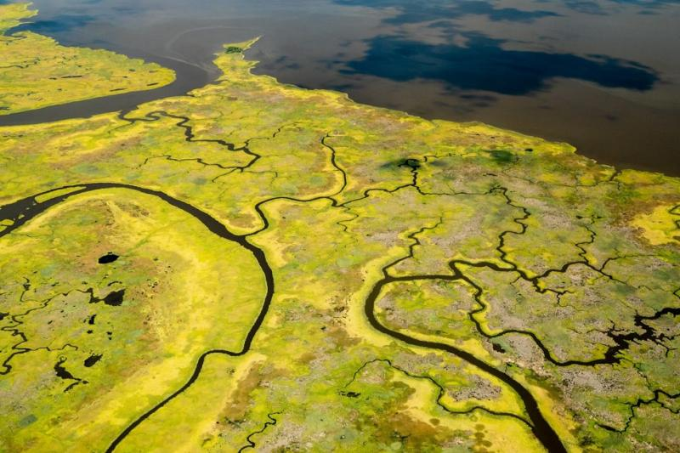
Photo Credit: Will Parson/Chesapeake Bay Program
- Avoid Noise Interference and Disturbance
  - Birds: Place ARUs away from nesting areas of loud species like eagles or ospreys, which can overwhelm acoustic data.
  - Human Activity: Avoid sites near walking trails, fishing hotspots, or areas prone to vandalism.
    - Consider using a security bracket for additional protection from tampering.
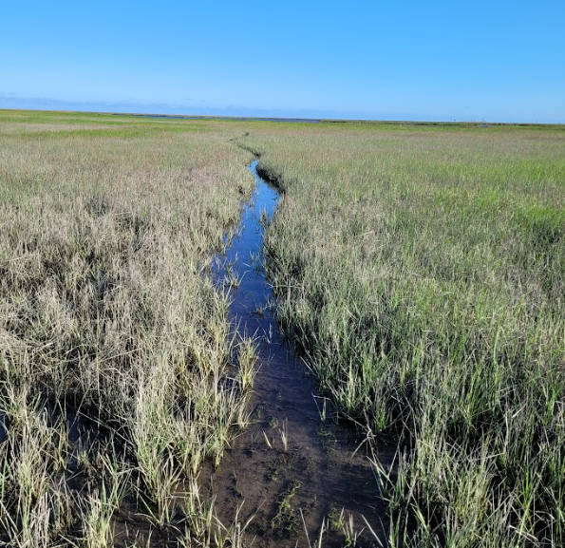
Fisherman footpath. Photo Credit: Kelly Faller
- Maintain Distance from Other ARUs
  - Maintain a minimum distance of 400 meters from the nearest ARU to prevent overlapping sound fields.
    - If feasible, increase the distance to further minimize acoustic interference. You want to ensure that when conducting species detections or soundscape analyses, you can trust that each recorder is picking up unique data for each location.
- Develop Reference Site Criteria (if applicable)
  - Select a reference site that matches the habitat conditions of the primary site:
    - For example, if the primary ARU is in a dense patch of Spartina patens close to a creek and 400 meters from the marsh edge, aim to replicate these conditions for the reference site.
- Consider Microphone Orientation
  - Orient the microphone to face the area of interest, whether it is a creek, marsh edge, or a specific vegetative zone. This is especially important if you are only using one microphone. Point it in the direction of the AOI.
- Consider Vegetation Structure
  - Aim for locations with minimal obstruction to sound propagation while maintaining coverage of the target habitat.
  - Avoid placing the ARU in dense or tall vegetation, such as Phragmites australis:
      - Dense vegetation can attenuate sound waves.
      - Tall vegetation often generates wind noise, masking target species' calls.
- Station Naming Scheme:
  - When the station location is determined and the ARU is mounted, it will have to be named.
    - Format:
- Stations are named using a shortened version of the site name followed by a unique number for that site.
- For consistency, always include an underscore (_) between the site abbreviation and the station number.
    - Abbreviations:
- Use a concise, intuitive abbreviation for the site name.
- Example abbreviations:
  - Port Mahon → PM
  - Garrison → GAR
  - Russell Farm → RF
    - Unique Numbers:
- Assign each station a unique, sequential number within the site.
- The first station in a site is 01, the second is 02, and so on.
- Examples:
  - Port Mahon:
    - Site name: Port Mahon
    - Station names: PM_01, PM_02, PM_03, etc.
  - Garrison:
    - Site name: Garrison
    - Station names: GAR_01, GAR_02, GAR_03, etc.
  - Russell Farm:
    - Site name: Russell Farm
    - Station names: RF_01, RF_02, RF_03, etc.

4.2 ARU Device Deployment (Beginning of Season)
The following are general procedures for the initial deployment of all ARU models. See the model-specific instructions for how to program specific models.
1. Mounting the ARU
  - Choose a Secure Mounting Location
    - Use your selected sites as a guide to where to deploy.
    - Select a stable, elevated site where the ARU will remain above average high tide and free from obstructions.
    - Avoid locations prone to high vegetation rustling, excessive wind exposure, or human disturbance.
    - Consider using a camouflaged mounting location in areas with public access to reduce the risk of vandalism or tampering.
      - Place units slightly off trails to reduce visibility to the public.
  - Attach the device securely to a PVC pole, metal stake, wooden post, or an existing sturdy structure (e.g., tree or piling).
    - If deploying in soft sediment or areas with tidal flow, ensure the pole/stake is buried deep enough (at least 1-2 ft.) to prevent movement.
    - For long-term deployments, use rebar or something to anchor in highly dynamic environments.
    - Face the microphone towards the area of interest
  - Mounting Precautions:
    - Ensure the ARU is mounted securely and tightly to prevent movement:
      - Use robust mounting equipment (e.g., zip ties, stakes) and double-check stability. Shake it a few times before leaving.
      - Avoid any elements that could generate noise in windy conditions:
        - Snip excess zip tie lengths.
        - Ensure all hardware and fasteners are firmly tightened.
  - Program the Device: See model-specific instructions below for more info.
  - Use pre-configured settings specific to your project.
  - Double-check recording schedules and naming conventions (e.g., site and station names).
  - Perform a Test Recording:
  - Verify audio quality and functionality by initiating a short recording.
  - Include a voice stamp with details (e.g., site ID, station name, date, time, crew members).
  - Documentation and Photos
  - Datasheets:
    - Fill out all fields in the deployment datasheet (e.g., site name, coordinates, deployment time, date).
      - Project_Data/Docs/Datasheets/
    - Record the coordinates accurately to avoid misplacement.
    - Do not rely on your memory to fill in information later.
  - Photos:
    - After the ARU is mounted and secure, take photos of the ARU from all cardinal directions.
    - You want to capture the setup, adjacent habitat, and site features.
    - Photos should be taken of the inside and outside of the ARU housing.
    - When checking photos, ensure they are not blurry and obscured. Make sure the photo is level, well-framed, and taken in all cardinal directions. Photos must be clear and representative.
    - Label the photos with the year, station, ARU present, directionality, and whether it is a deployment, retrieval, or SD card check.
      - Example: 2024_PM_01_SMM05_NW_Deployment.
    - Add to file structure: Project_Data/Year/Photos/[Site]/[Deployment_#]/[ Cardinal Direction]/
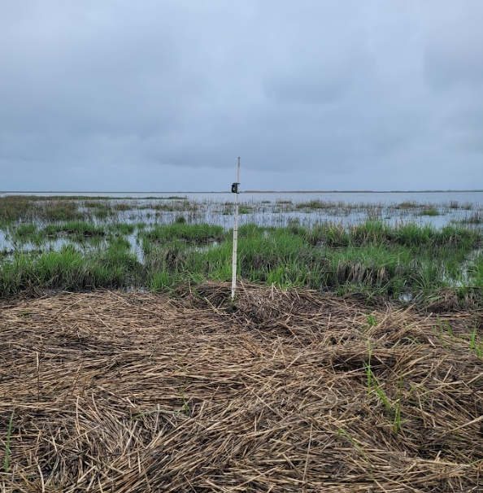
ARU deployment photo showing habitat conditions. Photo Credit: Kelly Faller.

Model-Specific Instructions
See Section 11 for troubleshooting tips.

- SM4 Model:
These units should be pre-configured and ready to go into the field. It saves time and is more accurate when the units are ready to go when they leave the office.
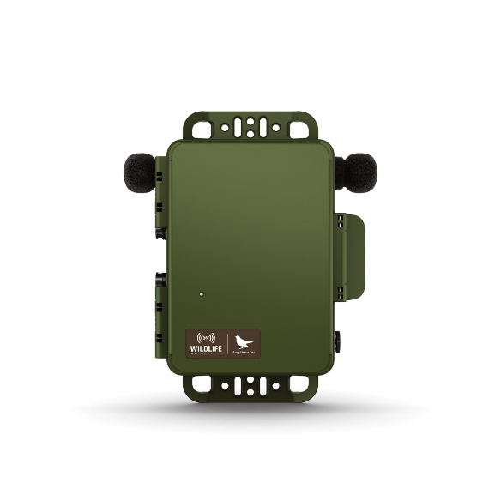
Wildlife Acoustics SM4 Model. Photo credit: Wildlife Acoustics
- Power On the Unit
  - Open the casing and turn on the ARU by sliding the power switch DOWN to activate the internal battery.
  - Wait for the unit to initialize.
- Verify Date and Time
  - Push the Check Status button once to confirm the date and time. Adjust as needed.
  - Note: The ARUs are programmed for daylight savings time. Verify if adjustments are necessary based on the current date.
- Set Location Prefix
  - Navigate to the Main Menu using the directional arrows and press Enter/Menu.
  - Scroll to Settings, then select Location and press Enter/Menu.
  - Choose Prefix and input the appropriate site and station identifier using the arrow keys. Use the designated naming format mentioned in the above section.
- Test Recording with Voice Stamp
  - Press and hold the Up and Down arrow keys simultaneously to start a test recording.
- Stop Test Recording
  - Once the voice stamp is complete, press Schedule Stop to end the test recording.
- Start Recording Schedule
  - Press the Schedule Start button to activate the programmed recording schedule.
  - Confirm the message displayed: “Going to sleep until <date and time>.”
  - The date and time shown should match the programmed start time in the configuration file.
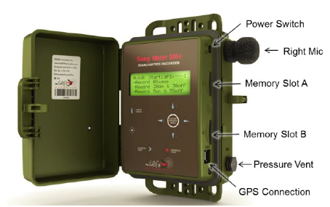
Wildlife Acoustics SM4 Model. Photo credit: Wildlife Acoustics
- Song Meter Mini (all models): See Section 11 for troubleshooting tips.
- Connect via Bluetooth:
  - Open the Song Meter Configurator App on your mobile device.
  - Pair the ARU by holding the pair button on the unit for ~3 seconds. Press the pair button on your screen when it pops up.
- Load Configuration:
  - Import pre-saved configuration files or create a new setup.
  - Adjust recording schedules, start/stop times, frequency ranges, and gain based on the details in Appendix A.
- Verify Settings:
  - On the Utilities tab, test the microphone to ensure it is working properly.
  - Ensure that the SD card does not have an error.
  - Ensure the device date and time are accurate.
  - Double-check the naming convention (site and station prefix).
- Schedule Activation: Start the programmed schedule via the app.
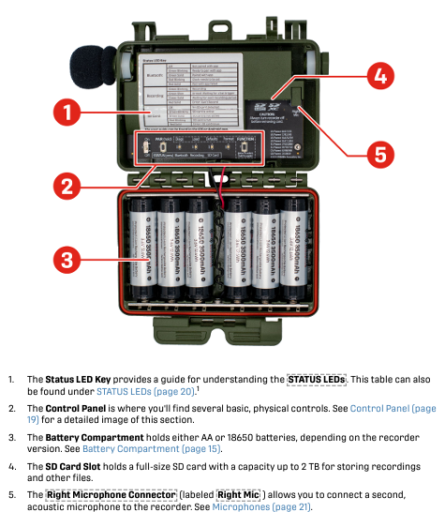
Wildlife Acoustics Song Meter Mini 2 Lithium-Ion Model. Photo credit: Wildlife Acoustics

4.3 Post-Deployment Procedures (in office):
After initial deployment, site information collected in the field should be digitized.
- Transfer photos into their respective folders. Use the standardized directory structure:
  - See Section 7.1 for more information.
  - Project_Data/Year/Photos/[Site]/[Station]/[Deployment_#]/ [Cardinal Direction]/
- Enter deployment data from the datasheet into tracking datasheets
  - Project_Data/Docs/Datasheets/
  - Project_Data/Year/Metadata/Equipment_Tracking.xlsx
- Enter site locations into Arbimon, including site name, latitude, and longitude.

5. ARU Maintenance and Regular Check Procedures (Mid-season)
For use between deployment and final retrieval. This procedure ensures that ARUs remain operational and protected throughout the deployment period, minimizing data loss and maintenance needs.
- Checklist of Items to Bring:
  - Spare SD cards.
  - Fully charged batteries.
  - Extra windscreens.
  - Nitrile gloves.
  - Cleaning wipes and alcohol pads.
  - Ammonia wipes.
  - Small brush or microfiber cloth.
  - Zip ties, wire cutters, and extra mounting hardware.
    - Zip ties are also used for creating bird spikes - bring a lot!
  - Ant deterrent supplies (e.g., ant gel bait).
  - Field datasheets, clipboard, and pencils.
  - Dry bags.
In the Field:
- Swap SD Cards and Batteries
  - Power Down the ARU: This is important to do first!!!!! If you do not power off the ARU before removing SD cards, the SD cards can corrupt.
    - For SM4: Press Stop Program to safely stop recording.
    - For Song Meter Mini 2: Use the app or power button to stop recording.
  - Remove SD Cards:
    - Safely eject SD cards and place them into labeled SD card carrying cases. Keep this in a dry bag.
    - Note the unit ID, site, and station on the datasheet.
  - Install Fresh SD Cards:
    - Insert formatted and labeled SD cards into the appropriate slots.
    - Ensure the SD cards are securely seated in the unit.
    - Note this information on the datasheet.
- Replace Batteries
  - Replace batteries even if the ARU still has a charge. Always start fresh.
  - Ensure correct orientation and secure closure of the battery compartment to maintain waterproofing.
- Inspect and Clean the ARU
  - If there is a lot of evidence of bird perching and pooping, create bird spikes:
    - Attach zip ties to the top of the ARU housing to deter birds from perching. Here is an example of how to do it. We call it “the crown of thorns”: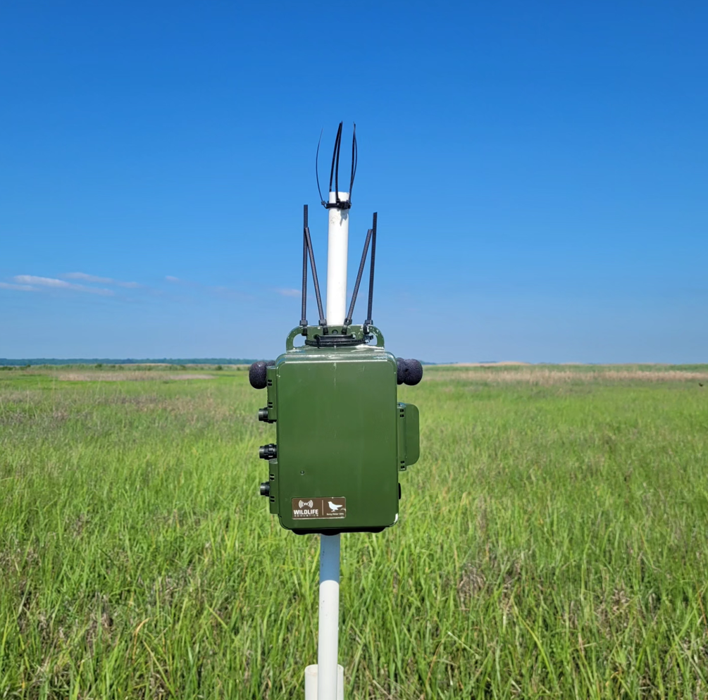
ARU with zip tie bird spikes. Photo Credit: Kelly Faller
    - You can also purchase bird spikes online. They are very effective, since they are designed for this purpose. They require adhering to a solid object, like a back plate for an ARU (such as the Cornell SwiftOne shown below). This may not be possible with all acoustic setups. In a pinch, zip ties work just fine.
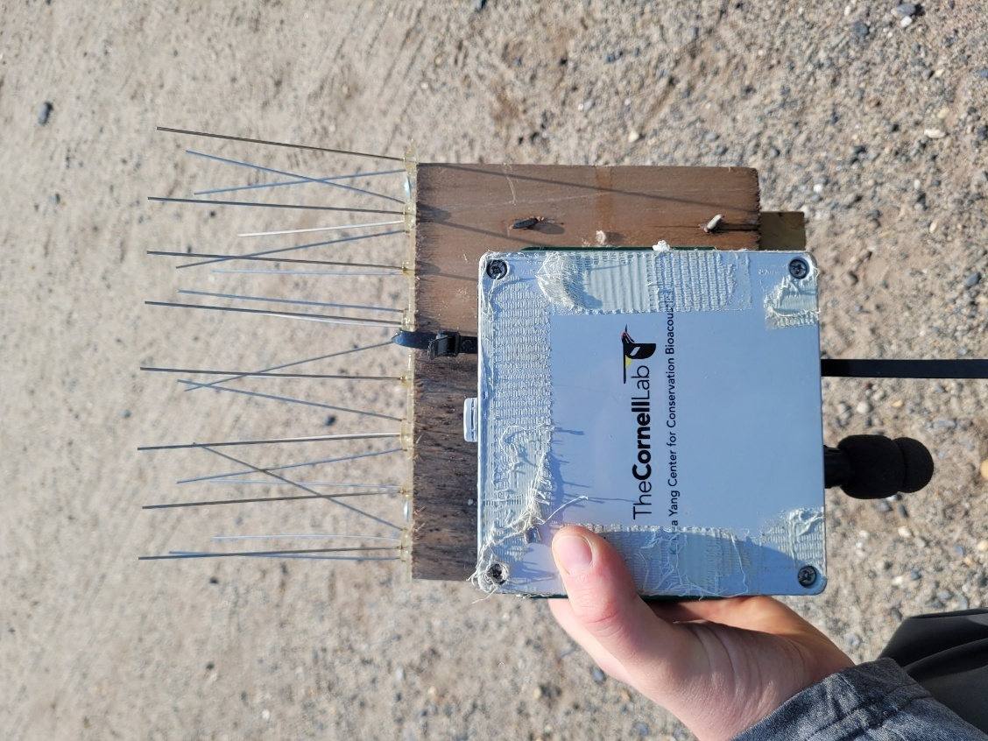
ARU with bird spikes mounted onto a plywood back plate. Photo Credit: Kelly Faller
  - Ensure the spikes do not interfere with the microphone and that their noise generation would be nominal.
  - Clean Bird Poop Off the ARU:
    - Use nitrile gloves to protect your hands.
    - Wipe off bird poop with cleaning wipes or alcohol pads.
  - ⚠️ Important notes:
    - Poop is highly corrosive and can damage the waterproof gaskets, microphones, and casing if left unattended.
    - Regular cleaning prevents degradation of the unit’s integrity.
- Inspect the Unit for Wildlife Activity
  - Raccoons:
    - Look for bite marks, scratches, or attempts to open the casing.
    - Secure the ARU with additional mounting hardware if raccoon interference is observed.
    - Use scent deterrents like vinegar or ammonia wipes around the mounting area, but do not apply directly to the ARU.
    - The most common raccoon damage is an eaten windscreen.
    - Baffling can be used to keep raccoons off ARU if the issue persists.
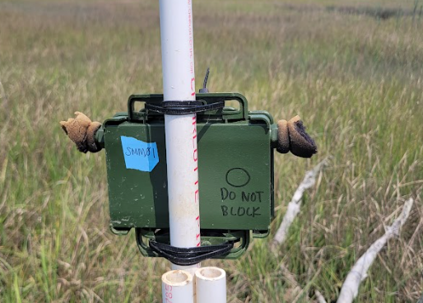
ARU with raccoon damage. Photo Credit: Kelly Faller
  - Ants:
    - Inspect inside the casing for ants or nests.
    - Use a small brush or microfiber cloth to remove ants.
    - Apply a barrier (e.g., ant deterrent gel) on the mounting area to deter further activity.
      - Ensure it is high enough on the mounting surface and above the MHHW line. It could be washed away otherwise.
- General Inspection
  - Check for physical damage, including cracks, water intrusion, or wear on the microphone and casing.
  - Ensure all seals and gaskets are intact to maintain waterproofing.
- Replace Windscreens (if necessary)
  - A common issue with windscreens in the salt marsh is UV damage. The sun very quickly begins to degrade the foam. This is what it can look like after only a month or so:
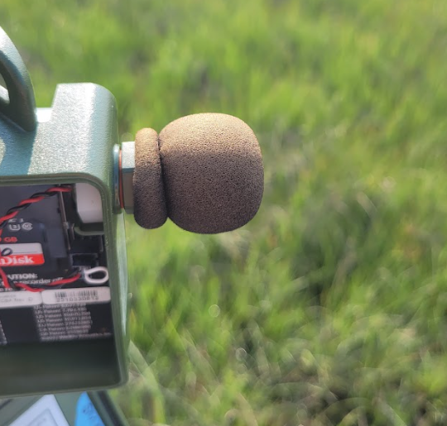
ARU microphone windscreen with UV damage. Photo Credit: Kelly Faller
- Verify Functionality
  - Perform a Test Recording:
    - Record a short audio clip and review the playback for clarity.
    - Include a voice stamp to document the site and station during the maintenance visit.
  - Check Configuration Settings:
    - Verify the time, date, and recording schedule.
    - Reapply or adjust settings if necessary.
- Documentation
  - Fill Out the Maintenance Datasheet:
    - Record the date, site, SD card, and station details.
    - Note any observations (e.g., wildlife activity, physical damage, cleaning performed).
  - Photograph the Unit:
    - Capture photos of the ARU from multiple angles, including the mounting setup and surrounding habitat.
- Final Steps
  - Re-secure the ARU:
    - Double-check all mounting hardware and ensure the unit is stable.
  - Activate the Recording Schedule:
    - For SM4: Press Start Program and confirm the “Going to sleep” message.
    - For Mini 2: Use the app to resume the recording schedule.
- Repack Tools and Supplies:
  - Safely store removed SD cards and batteries for transport back to the office. Use dry bags for any electronics or batteries.
⚠️ Important notes:
- Regular Maintenance: Check ARUs every 2–4 weeks, depending on site conditions and deployment duration.
- Weather Precautions: Conduct checks during dry conditions when possible. Avoid moisture damage while the unit is open.
- Preventative Measures: Regular cleaning and inspection reduce the likelihood of long-term damage and ensure uninterrupted data collection.

6. Retrieval Process (End of Season)

6.1 Standard Equipment
- Personal gear: Dress for the weather, bring lots of water and sunscreen, and ensure you have any required safety equipment.
- SD card holder
- Dry bags
- Phone or tablet for photos
- Datasheet, clipboard, and pencils
- Scissors or wire cutters
- Optional: yellow coin envelopes

6.2 Deactivating the ARUs
1. Before Deactivation
- Prepare Necessary Tools:
  - From the above list.
- Confirm Location:
  - Verify the ARU’s location using GPS or datasheets.
  - Ensure you are at the correct site and station.
2. Deactivation Steps
- Take Photos Before Removal:
  - Capture clear photos of the ARU in its mounted position and its surroundings.
  - Photograph the mounting setup (stakes, PVC poles, or straps) and surrounding environment in all cardinal directions.
  - Verify the photos are clear and well-framed before proceeding.
- Stop the Recording Schedule:
  - For Song Meter Mini 2: Use the Song Meter Configurator App to stop the schedule.
  - For SM4: Press the Schedule Stop button inside the unit. Verify the recording has stopped.
- Power Down the Unit: Note: This is crucial to do before ejecting SD cards!
  - For Mini 2: Turn off using the power button.
  - For SM4: Slide the power switch UP to deactivate the internal battery.
- Retrieve SD Cards:
  - Eject all SD cards carefully and place them in the SD card case. Put that in a dry bag.
  - Ensure the datasheet has the site name, station name, and retrieval date for that SD card.
  - Optionally, you could put the SD cards into labeled yellow coin envelopes with the site, station, and date. This will reduce confusion later in case the datasheet is lost.
- Disassemble the Mounting Setup:
  - Remove stakes, PVC, zip ties, or other mounting hardware.
  - Ensure all materials are accounted for and no debris or equipment is left behind.
3. After Deactivation
- Check for Remaining Items:
  - Walk around the area to confirm nothing has been left at the site.
- Transport Equipment:
  - Securely pack the ARU and all components for transport.
- Documentation:
  - Record the date, time, and site/station name, SD card ID in the datasheet.

6.3 In-Office (After ARU Maintenance Checks and Final Retrieval)
Transfer and Backup Data
- SD Card Handling:
  - After retrieval, SD cards must be handled with care to prevent data mix-ups.
  - For interns:
    - Place each SD card in a labeled coin envelope (e.g., Site, Station, Deployment Dates).
    - Group envelopes from the same site in a larger envelope labeled with the site name.
    - Submit all envelopes to the supervisor for upload.
  - For supervisors:
    - Transfer all SD card contents to an external hard drive as soon as possible. Use the file structure mentioned below in Section 7.
    - Verify all files have been successfully copied by cross-checking file counts and sizes.
    - Store SD cards that have been uploaded in a “Processed” container, and separate unprocessed cards to avoid confusion.
- Backup and Redundancy:
  - Maintain duplicates of data:
    - Primary Copy: On a secure external hard drive to function as an archive.
    - Secondary Copy: On a secure external hard drive meant to be a “working” hard drive, rather than for storage and archival purposes
    - Third Copy: In cloud storage (e.g., Arbimon).
- On the retrieval datasheet, record the condition of the ARU:
  - Physical Condition:
    - Excellent: No damage; no repairs needed.
    - Good: Minor damage, such as cosmetic scratches or chewed windscreens, that does not affect functionality.
    - Fair: Damage may affect functionality, e.g., poop on microphones or casing.
    - Poor: Major damage, e.g., water damage, broken microphones.
  - Mechanical Condition:
    - OK: Device operated as expected.
    - Check: Issues such as mechanical errors, malfunctions, or firmware problems.

7. Data Management
Proper data management ensures the integrity and accessibility of audio recordings and associated metadata. This section details file organization, uploading protocols, and redundancy practices.

7.1 File Organization (Hard Drives – Raw Audio Management)

⚠️ This section applies specifically to organizing the raw audio files pulled directly from SD cards after field deployments. This is your primary local storage and working directory for housing the full-resolution WAV files and associated field data on external hard drives or internal drives before processing.

The folder structure used in this project is designed to promote clarity, consistency, and scalability across field seasons. All data from a given year is grouped under a dedicated [Year] folder to keep seasonal deployments organized and easy to manage. This format allows for efficient collaboration, reduces the risk of data loss or confusion, and supports integration with analysis pipelines. See section 3.1 for folder structure.

Key folder components:
- Raw/
Contains unprocessed audio recordings, organized by site, station, and deployment.
- Metadata/
Hosts equipment tracking logs, deployment logs, pattern matching tracking sheets, and calibration records. Consistent metadata logging is critical for maintaining data integrity and reproducibility.
- Config/
Stores ARU configuration files, allowing easy access to device settings used during each field season.
- Photos/
Stores site, station, and deployment documentation images. This visual metadata is important for contextualizing acoustic data and verifying field conditions.
- Docs/
Documents for the project (e.g., this manual, SOPs). Remains at the top level since they are not specific to any single field season.

7.2 Data Uploads

Hard Drives
      - Transfer all raw audio files from SD cards to your designated external and working drive, following the standardized structure:
Project_Data/
└── [Year]/
└── Raw/
└─[SiteName]/[StationID]/Deployment_[#]_[StartDate]-[EndDate]/[ARU ID]/[*].WAV
      - Confirm file counts and deployment dates, and log each deployment in:
Project_Data/[Year]/Metadata/Deployment_Log.csv

Arbimon
- Install Arbimon Uploader:
  - Download and install the Arbimon Uploader from the Arbimon website.
  - Log in using your project credentials.
- Prepare Files for Upload:
  - Ensure your files are organized by deployment site and date before upload.
  - Confirm that all audio files are intact and properly named.
- Upload Audio Files:
  - Open Arbimon Uploader and navigate to the folder containing your audio recordings.
  - Select the desired files or folders for upload.
  - Assign each upload to its corresponding site and station within Arbimon.
- Verify Uploads:
  - Check the upload status in Arbimon Uploader to confirm that all files were successfully uploaded.
  - Verify that all metadata was extracted from the file names.
  - Log the upload completion in your project tracking sheet. Project_Data/Year/Metadata/Deployment_Log.csv
- Organize in Arbimon:
  - Create a playlist within Arbimon for each deployment. To do so, follow these steps:
    - Open Arbimon on the website
    - Navigate to Recordings
      - From the dashboard, click on the Recordings tab in the navigation menu.
      - This will display all the audio files uploaded to your project.
    - Filter for Specific Recordings
      - Use the Filters option to narrow down the recordings:
        - Station: Select the station corresponding to the ARU deployment.
        - Dates: Set the date range for the period your ARU was active during deployment.
      - Apply the filters to view only the recordings relevant to your desired station and deployment period.
    - Add Recordings to a Playlist
      - Check the Select All option at the top of the list.
      - Click the Add to Playlist button (usually located at the top of the recordings table). A dialog box will appear to configure the playlist.
    - Name the Playlist
      - Enter the playlist name using the station ID and deployment number.
        - Example format: PM_01 Deployment 1
      - Click Save to finalize the playlist creation.
    - Verify Playlist
      - Navigate to the Playlists section in Arbimon to confirm the new playlist has been created.
      - Open the playlist to ensure all recordings made it into the playlist by comparing the number of recordings in the playlist with the number of recordings in the hard drive folder for that deployment.

7.3 GitHub and R
Efficient organization within your GitHub repository is critical for streamlined data preparation, analysis, collaboration, and reproducibility. The GitHub repository structure largely mirrors the local Project_Data folder hierarchy to maintain consistency across workflows, ensuring that scripts, metadata, and outputs are easy to manage and link back to field deployments.
GitHub Desktop Integration
The GitHub repository is linked to your local computer using GitHub Desktop, which allows you to:
- Pull updated scripts, documentation, and metadata from the GitHub server to your local machine.
- Push changes from your local working environment to the GitHub server for sharing and version control.
- Maintain a clean version history, support collaborative editing, and resolve conflicts when multiple users contribute.
This setup ensures that everyone on the team is working from the same version-controlled repository, while large files like .WAV audio remain stored externally (e.g., external drives or Zenodo) to avoid GitHub’s file size limitations.
Useful SOP:
Project_Data/Docs/SOPs/Github_Repository_Structure.docx
Base Repository Structure
[repository-name]/
├── .github/
├── 01_Data_Prep_Scripts/
├── 02_Analysis_Scripts/
├── Audio/
│ └── README.md
├── Data/
│ ├── Arbimon_Data/
│ │ └── [Year]/
│ ├── BirdNET_Species_ID_Files/
│ │ └── [Year]/
│ ├── Kaleidoscope_Acoustic_Index_Files/
│ │ └── [Year]/
│ ├── Kaleidoscope_SPL_Files/
│ │ └── [Year]/
│ └── Metadata/
│ └── [Year]/
│ ├── Equipment_Tracking.xlsx
│ ├── Pattern_Matching_Tracker.xlsx
│ ├── Deployment_Log.csv
│ ├── Notes/
│ └── Audio_Calibration/
├── Docs/
│ ├── Acoustic_Manual.pdf
│ └── SOPs/
├── Images/
├── Outputs/
│ ├── Species_Detections/
│ ├── Graphics/
│ └── Summary_Stats/
├── .gitignore
├── LICENSE
└── README.md

Instructions for Organization
Arbimon_Data/
Includes all data outputs retrieved as backups from the Arbimon platform.
- Backup Instructions:
  - Log in to Arbimon and request a backup of all relevant project data.
  - Download and store the backup here, preserving the original folder structure.
BirdNET_Species_ID_Files/
Stores processed outputs from BirdNET GUI Analyzer.
- File Naming Convention:
Rename output files using this format:
StationID_Date.csv
Example: GAR_02_4-28-24.csv
- These outputs may represent partial deployments due to the time-intensive nature of BirdNET processing.
Kaleidoscope_Acoustic_Index_Files/
Processed data from Kaleidoscope’s acoustic index analysis.
- File Renaming Format:
<Station>_<Deployment>_acousticindex.csv
Example: GAR_02_02_acousticindex.csv
- Column Standardization:
Add the following columns to all files. This metadata is critical to the analysis stage and is not created in the Kaleidoscope outputs, so it will have to be manually added to each CSV. Note: capitalization and lower case for column headers must be matched perfectly, or the R scripts will not work.:
  - SITE
  - STATION
  - DEPLOYMENT
- Data Prep Script Tasks:
  - Bind files across years into a master dataset.
  - Add DATETIME and YEAR columns for use in downstream analysis.
Kaleidoscope_SPL_Files/
Processed data from Kaleidoscope’s Sound Pressure Level (SPL) analysis.
- File Renaming Format:
<Station>_<Deployment>_spl.csv
Example: GAR_02_02_spl.csv
- Column Standardization:
Add the following columns to each SPL file. This metadata is critical to the analysis stage and is not created in the Kaleidoscope outputs, so it will have to be manually added to each CSV. Note: capitalization and lower case for column headers must be matched perfectly, or the R scripts will not work.:
  - Site
  - Station
  - Deployment
- Data Prep Script Tasks:
  - Consolidate annual SPL files into one dataset.
  - Add Datetime and Year columns for consistency with acoustic indices.

8. Analysis
Overview:
- R Code and GitHub Repository:
  - All data preparation and analysis scripts are stored in the GitHub repository under:
    - [repository-name]/01_Data_Prep_Scripts/
    - [repository-name]/02_Analysis_Scripts/
  - Use the provided R scripts to streamline analysis:
    - A data preparation script ensures consistent formatting, merges datasets across years, and integrates metadata (see Section 7.3).
    - Visualization scripts (in R Markdown) generate plots and summary graphics from processed outputs such as acoustic indices and SPL data.
      - [repository-name]/02_Analysis_Scripts/02-Acoustic_Analysis.rmd
    - A calculation script for acoustic indices and SPL analysis is currently in development. For now, these metrics are generated using Kaleidoscope Pro (see Section 8.1)
      - [repository-name]/01_Data_Prep_Scripts/Acoustic_Calculation.rmd
  - Each script is version-controlled through GitHub and linked to a consistent folder structure (see Section 7.1).
- Acoustic Indices and SPL Analysis
- Use Kaleidoscope Pro to calculate indices and SPL:
  - Acoustic Indices:
    - Calculate metrics like ACI, ADI, NDSI, and BI.
  - SPL Analysis:
    - Ensure microphone sensitivity calibration is incorporated.
    - Use weighted dB bands and apply corrections as needed.
- Arbimon Analysis:
  - Use pattern matching and random forest modeling to identify species presence.
  - Validate automated identifications to ensure accuracy.
- BirdNET (not included):
  - Run recordings through BirdNET for bird species detections. Due to the inconsistencies of the results, BirdNET is not overviewed in this manual.

8.1 Kaleidoscope Pro
Kaleidoscope Pro, developed by Wildlife Acoustics, is a widely used tool for efficiently generating acoustic indices and conducting SPL (Sound Pressure Level) analysis. While it is not a free software, it provides a user-friendly interface and robust batch processing capabilities, making it a practical choice for streamlining acoustic data processing in the field and lab.
In a future version of this manual (v3.0), I will aim to replace this dependency with an open-source workflow. An Acoustic_Calculation.Rmd script is currently in development and will eventually provide a fully R-based alternative for calculating indices and SPL from raw audio files.
- Preparing for Analysis
  - Install Kaleidoscope Pro:
    - Download and install the latest version of Kaleidoscope Pro from Wildlife Acoustics. It will require a license to be activated.
  - Open Kaleidoscope Pro:
    - Launch the software.
  - Orient Kaleidoscope to Your Data:
    - For the input directory, open the raw audio files that you would like to run. This should be under the designated folder structure in Section 3.1.
    - For the output directory, open the folder created to house the outputs. This should be under the designated folder structure in Section 3.1.
- Conduct Sound Pressure Level (SPL) Analysis. This will be done simultaneously with the Acoustic Index Analysis.
  - Configure SPL Settings:
i. Go to the SPL Analysis tab and adjust the following parameters:
      - Weighted Bands: Select A Weighted to measure frequencies from 20 Hz to 20 kHz, simulating human hearing sensitivity.
      - dB Adjustment: Set to 94 dB to align 0 dB with 20 µPa (standard for "silence").
      - Sample Period: Set to 2 minutes to match the device recording intervals.
  - Run the Analysis:
    - Click Start to begin processing.
    - Monitor the progress in the status window.
  - Check Results and Copy File:
    - Once completed, check the SPL results. They will be automatically added to the output folder as a .csv file.
    - Save the file using the naming convention outlined previously and add it to the GitHub repository.
- Conduct Acoustic Index Analyses. This will be done simultaneously with the SPL Analysis.
  - Configure Acoustic Index Settings:
    - Go to the Acoustic Indices tab and set parameters for each index: Important: these may vary depending on the site and project goals! See Appendix A for more details.
      - ACI (Acoustic Complexity Index):
- Frequency Min: 500 Hz
- Frequency Max: 14,000 Hz
- Default settings for J and Threshold.
- ADI (Acoustic Diversity Index):
- Frequency Min: 500 Hz
- Frequency Max: 14,000 Hz
- Frequency Step: 1,000 Hz
- Threshold: -50 dB
- NDSI (Normalized Difference Soundscape Index):
- Anthrophony: 500–1,500 Hz
- Biophony: 1,500–14,000 Hz
- BI (Bioacoustic Index):
- Frequency Min: 1,500 Hz
- Frequency Max: 14,000 Hz
- FFT Size: 512
b. Run the Analysis:
    - Click Start to begin processing.
    - Monitor the progress in the status window.
c. Check Results and Copy File:
i. Once completed, the results will be automatically uploaded into the output folder as a .csv file.
ii. Save the file using the naming convention outlined previously and add it to the GitHub repository.

8.2 Arbimon Analysis
Overview of Arbimon
Arbimon is a powerful cloud-based platform initially developed to facilitate biodiversity monitoring in rainforests, developed by Rainforest Connection (RFCX). Its design aims to automate the analysis of complex soundscapes, focusing on the rich acoustic environments of tropical ecosystems.
While Arbimon excels in rainforest settings, its robust features make it equally effective for other ecosystems, such as salt marshes. I leverage Arbimon’s advanced tools to analyze salt marsh soundscapes, monitor soniferous species, and assess biodiversity in this unique habitat.
How Arbimon’s AI Works
Arbimon uses spectrogram-based image analysis to process and analyze audio recordings. The AI relies on visual patterns to identify specific sounds or species within the data:
- Spectrograms: A visual representation of audio where:
  - The x-axis represents time.
  - The y-axis represents frequency (Hz), typically from 0 Hz - 22 kHz.
  - Color intensity represents the amplitude (dB), with brighter or darker colors indicating louder sounds.
- AI pattern recognition:
  - Arbimon’s AI detects and compares patterns in spectrograms to known templates with annotated training data. This method enables accurate species detection and identification.
  - Through using Arbimon, you have the power to train the software using your own field recordings rather than other “black box” tools like BirdNET. This enables greater accuracy and more confidence in the outputs.
Key Definitions for Using Arbimon
- Spectrogram: A visual representation of sound over time and frequency, used for audio analysis in Arbimon.
- dB (Decibels): A measure of sound intensity; darker regions in Arbimon’s spectrograms indicate louder sounds.
- Template: A pre-selected audio snippet used for pattern matching to identify specific sounds.
- Pattern Matching: A method to detect specific sounds in recordings by comparing them to a template.
- Annotation: A label or tag applied to audio segments, marking the presence of species calls or environmental sounds.
- Random Forest Model: A machine learning algorithm used in Arbimon to classify and predict species occurrences based on annotated data. It uses presence/absence data collected through manual annotation of files or through pattern matching.
- Playlist: A curated collection of recordings grouped for analysis or sharing. For our purposes, it will be by deployment.
Overall Workflow in Arbimon
- Upload Audio Files: Use Arbimon Uploader to upload files from SD cards, organized by site, station, and deployment.
- Manual Review: Listen to recordings to scan for species, build templates, and familiarize yourself with the soundscape.
- Create Templates: Use unique, clear portions of species calls to create pattern matching templates.
- Create Playlists: Organize recordings by station and deployment for focused analysis. Limit playlist size for optimal processing.
- Run Pattern Matching Analyses: Apply templates to recordings to automatically identify target species across your playlists.
- Annotate and Review: Add annotations to recordings for species calls or environmental sounds, and review flagged pattern matches.
- Build Random Forest Models: Train machine learning models using annotated data to predict species occurrences.
- Validation and Insights: Randomly listen to recordings to ensure accuracy, gain insights, and maintain data quality.
Step-by-Step Instructions for Using Arbimon
1. Uploading Audio Files Using Arbimon Uploader:
- Open Arbimon Uploader and log in.
- Navigate to the folder containing your audio files.
- Select files or folders and assign them to the appropriate site and station in Arbimon.
- Verify metadata extraction (e.g., site, station, deployment information).
⚠️ Important note: Cornell SwiftOne units automatically organize recordings into subfolders by date. This will cause some headaches during the Arbimon upload, because you will feel like you have to upload each day separately.
To simplify the process:
- In the Arbimon Uploader, click Choose Files (instead of selecting folders).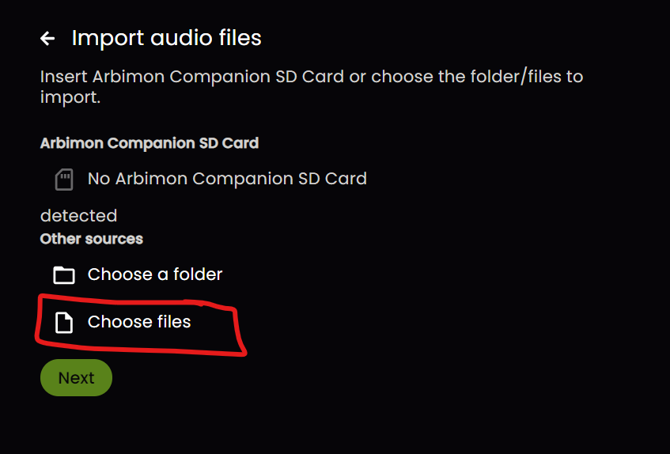
- Navigate to the main folder containing the SwiftOne recordings (the one holding all the daily subfolders).
- In the file selection window, type *.* into the search bar.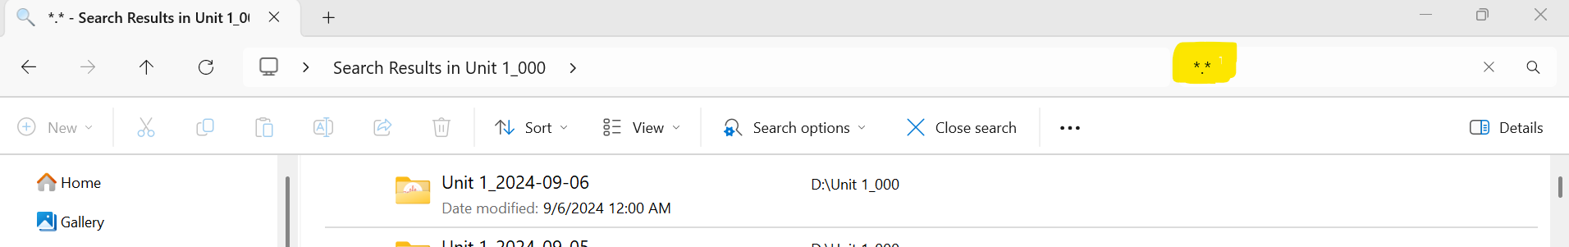
- This will reveal all audio files across the subfolders in one flat list.
- Use Shift+Click to select all files from the deployment, then upload them together.
This method saves time and avoids the need to upload each day's recordings separately.
2. Creating Playlists
Playlists help you organize and analyze recordings by station and deployment. You cannot complete any analysis in Arbimon without this step.
- Go to the Recordings under the Explore tab.
- Filter Recordings:
  - Click the “Filters” button
  - Apply filters based on site, station, and date range to isolate the recordings you want to include in the playlist.
    - Tip: Create one playlist per site per deployment.
    - If only one deployment occurred during the season, filter by site and year.
    - If the season was split into multiple deployments, filter by site and specific date range corresponding to that deployment.
- Select all filtered recordings
- Create Playlist:
  - Click Save to Playlist and name it using the station ID and deployment number.
  - Example: PM_01 Deployment 6.
- Manage Playlists:
  - Access the Playlists tab to edit, combine, or delete playlists.
    - Note, Playlists cannot be deleted if they are used in an analysis.
3. Manual Review of Recordings
Use this step to explore new sites or verify acoustic activity.
- Go to the Recordings tab and apply filters by site, station, or date.
- Click on a recording to listen and view the spectrogram.
- Identify species manually and add annotations to label calls or sounds of interest.
4. Creating Templates
Templates are short spectrogram clips used for pattern matching.
- Review audio for distinct, identifiable calls.
- Isolate the most unique portion of the call (e.g., a syllable or specific inflection).
- Highlight the call on the spectrogram and save it as a template.
  - Name it by species alpha code and the number of the template (in case you make multiple for the species).
    - Example: SALS 1
  - Store the information about the best alpha code for the species in the tracking sheet located here Project_Data/[Year]/Metadata/Pattern_Matching_Tracker.xlsx
Useful Tip:
Your template should be limited exclusively in both length and frequency range to the call of interest. Including background noise, harmonics, or additional syllables can reduce accuracy. It’s often useful to test multiple templates per species to determine which part of the vocalization yields the most reliable matches. For example, SALS (saltmarsh sparrow) calls tend to produce higher match rates when templates focus on specific segments of their vocalization rather than the entire call.
5. Running Pattern Matching Analyses
- Determine which species and deployment you want to analyze.
- Fill out the tracking sheet for what pattern matches have been conducted. Optionally, I also track how many presence detections I got. This information can be found during the Arbimon backup, but I like to have a quick reference guide to where rare species are across sites at a glance. Project_Data/Year/Metadata/Pattern_Matching_Tracker.xlsx
- Under the Audio Analyses tab, click Pattern Matching.
- Click New PM Job + button.
- Name the pattern matching analysis by the species, station, and deployment being run.
  - Example: SALS GAR_04 Deployment 6
- Select the template and playlist from dropdowns.
- Set parameters:
  - Matches per recording: Usually 1. This can be adjusted higher if we are interested in how many times a bird is calling. For just presence/absence data, 1 is all that is necessary. A higher number will enable you to increase detections, but it will take much longer to process.
  - Matches per site: Usually (no limit).
  - Thresholds: Usually 0.3. The threshold is the confidence cut-off. A threshold of 0.3 means the software is only showing us the results of calls it has an over 30% confidence in being the species we are interested in detecting.
- Run the analysis and review flagged matches in the spectrogram view.
- Refine the template if needed to improve accuracy.
6. Annotating and Reviewing Matches
- Listen to flagged matches to validate results.
- Add annotations to recordings for detected species or environmental sounds.
- Use annotations as training data for further analysis.
7. Building Random Forest Models
A. Creating a Training Set. The training set forms the foundation for building a reliable Random Forest model.
- Go to the Random Forest Models page under Audio analyses and click the Training Set tab.
  - Click New Training Set + and use a clear naming convention to identify the species and call type.
    - Example: Bubo_virginianus_GHOW (scientific names followed by the species alpha code).
- Set Type to "ROI Set" (default).
- Select sounds using previously annotated recordings:
- Choose species and specific call types (e.g., song vs. territorial).
- Review selections and save the training set.

⚠️ Important note: These training sets can be shared across projects and combined with other training sets. That means you don’t have to start from scratch if you start a new project and are working on the same species. Also, you can collaborate across projects. Basically, this means that the presence/absence data from one project can be used in another.

B. Starting a Training Job
- Click New Training Job +.
- Name the job clearly:
  - Example: SALS V1 Aug 2024 (species alpha code, model version, and date).
- Choose the training set and set the classifier to “Pattern Matching with Random Forests.”
- Click Start Training.
- Review the output for:
  - Accuracy
  - Precision
  - General performance
  - If results are unsatisfactory, revise the training set and retrain.
C. Performing a Classification Job:
After building a model, use it to classify recordings across a specific dataset.
- Start a New Classification Job:
  - Click the Classification Job button on the Random Forest page.
- Name the Classification Job:
  - Use a clear and detailed name:
    - Example: SALS V1 Aug 2024: GAR_01 Deployment 1 (model name, date, site, and deployment).
- Select the Model:
  - Choose the trained Random Forest model from the list of available models if it is not the only option. It should be the only option available.
- Select the Playlist:
  - Choose the playlist containing the recordings to classify.
  - Ensure the playlist size is manageable (e.g., fewer than 5,000 recordings) for faster processing.
- Run the Classification Job:
  - Click Start Classification to begin processing.
  - Monitor progress and ensure all files are classified.
- Export Results:
  - Once complete, download the output as a .csv file.
  - Use this file to review classifications and validate results manually.
Tips for Success
- Validation is key: Always listen to a subset of detections to verify accuracy.
- Refinement is expected: Iteratively improve templates or training sets based on model results.
- Consistent naming: Use standardized formats for templates, playlists, models, and jobs.
- Track everything: Record all work in Pattern_Matching_Tracker.xlsx, including:
  - Dates
  - Accuracy scores
  - Notes on refinements
- Quality control:
  - Randomly spot-check recordings.
  - Compare manual vs. automated detections.

8.3 Arbimon Backup & Repository Integration
Overview
After completing all analysis tasks in Arbimon (manual review, pattern matching, and/or random forest classification), it's important to download and back up all results. These backups ensure the reproducibility of your work and allow for local data analysis and validation using R scripts. This can only be requested once every 7 days. It can take up to 24 hours to generate (although it is usually much faster), so prepare accordingly.

This backup contains all associated metadata, results, and relationships between species, sites, and recordings. These files must be processed locally to convert Arbimon's internal IDs into usable species detection outputs.

Requesting a Backup from Arbimon
- Log to your Arbimon project via the Arbimon platform.
- Navigate to the Project Settings section.
- Locate and select the option to request backup.
- Arbimon will generate a downloadable .zip file and email a link once it's ready.

Folder Contents
After unzipping the Arbimon backup, you’ll find several files, including:
Arbimon_Backup/
├── pattern_matching_rois.0001
├── pattern_matchings.0001
├── rfm_classifications.0001
├── recordings.0001
├── playlist_recordings.0001
├── playlists.0001
├── recording_validations.0001
├── templates.0001
├── sites.0001
├── species.0001

Depending on how much data is stored on Arbimon, you will likely get more than one file for things like recordings and pattern matchings. This will be handled in the [repository-name]/01_Data_Prep_Scripts/.
⚠️ Important notes:
- Do not rename these files. The R script depends on their structure.
- Arbimon does not include species names directly in pattern-matching outputs.
Instead, each species is represented by a numerical ID (e.g., 20377, which is the Chuck-wills-widow).
  - The ID must be cross-referenced with the species.0001 file to determine:
    - Common Name
    - Scientific Name
  - The same applies to site and station metadata as well as playlists, etc. Basically, all the metadata is spread across multiple CSVs.
- All of these metadata connections are handled automatically in the data prep R script [repository-name]/01_Data_Prep_Scripts/.

Storing in the GitHub Repository
The processed Arbimon data should be extracted and copied into the following structure in your GitHub repository under

acoustic-monitoring-project/
└── Data/
└── Arbimon_Data/
└── [Year]/
├── Raw/
│ ├── pattern_matchings.0001
│ ├── species.0001
│ ├── recordings.0001–.000X (aka the last one)
│ └── ...
├── Processed/
│ ├── pattern_matchings.csv
│ ├── rfm_classifications.csv
│ ├── validated_annotations.csv
│ └── metadata_linked_recordings.csv

Recommendations and Version Control Guidance
- Keep the full Raw/ untouched for reproducibility.
- Store cleaned outputs in Processed/.
- Commit files with appropriate messages, e.g.,
git commit -m "Add 2024 pattern matching results for SALS at GAR04"

8.4 Post-Processing in R
- Prepare Exported Data:
  - Ensure the SPL and Acoustic Index .csv files include additional columns for Site, Station, and Deployment (with proper capitalization mentioned in Section 7.3)
  - Use R data prep script to:
    - Combine SPL and Acoustic Index files into a single dataset, as mentioned in Section 7.3.
    - Add columns for Datetime and Year, as mentioned in Section 7.3.
- Load Data into Analysis Script:
  - Import the processed dataset into your RMD analysis script for data analysis and visualizations.

9. Post-Fieldwork: Workflow Diagram
Field Deployment Complete (yay!)
│
▼
1. Retrieve ARUs and Transfer Data
│
├─→ Copy raw audio to:
│ Project_Data/[Year]/Raw/[Site]/[Station]/Deployment_[#]/[ARU ID]/.WAV
│
├─→ Store two versions:
│ • Archived copy (unchanged, secure backup)
│ • Working copy (used for uploads, processing)
│
└─→ Follow the folder hierarchy defined in Section 3
▼
2. Pre-Processing
│
├─→ Verify filenames and directory structure
├─→ Record deployment in:
│ Project_Data/[Year]/Metadata/Deployment_Log.csv
├─→ Update equipment status in:
│ Project_Data/[Year]/Metadata/Equipment_Tracking.xlsx
└─→ Save photos to:
│ Project_Data/[Year]/Photos/[Site]/[Station]/[Deployment_#]/
▼
3. Upload Audio to Arbimon
│
├─→ Use Arbimon Uploader (see SwiftOne tips)
├─→ Assign files to correct site/station
└─→ Verify metadata extraction
▼
4. Create Arbimon Playlists
│
├─→ Filter by site + date range
└─→ Create one playlist per deployment
▼
5. Manual Review & Annotation
│
├─→ Listen to samples using spectrogram view
├─→ Annotate calls, note species presence
└─→ Identify unique calls for template creation
▼
6. Pattern Matching
│
├─→ Create templates (name as: SpeciesCode_Number)
├─→ Run Pattern Matching jobs
└─→ Log in:
Pattern_Matching_Tracker.xlsx
▼
7. Random Forest Classification
│
├─→ Build training set from annotated calls
├─→ Train Random Forest model
├─→ Review and revise model
└─→ Export detections and share
▼
8. Arbimon Backup & Results Extraction
│
├─→ Request a full project backup via Arbimon
├─→ Download and extract results:
│ • Pattern matches
│ • Random forest classifications
│ • Annotations
├─→ Organize files in:
│ Data/Arbimon_Data/[Year]/[Analysis_Type]/
└─→ Prepare for analysis using:
[repository-name]/01_Data_Prep_Scripts/
▼
9. Kaleidoscope Analysis
│
├─→ Run SPL & Acoustic Index processing simultaneously
├─→ Standardize columns by adding missing metadata
├─→ Rename outputs:
│ <Station>_<Deployment>_spl.csv
│ <Station>_<Deployment>_acousticindex.csv
└─→ Store in:
Data/Kaleidoscope_SPL_Files/[Year]/
Data/Kaleidoscope_Acoustic_Index_Files/[Year]/
▼
10. Data Cleaning & Standardization (R)
│
└─→ Run scripts from:
[repository-name]/01_Data_Prep_Scripts/
▼
11. Visualization & Reporting
│
├─→ Run scripts from:
[repository-name]/02_Analysis_Scripts/
├─→ Generate:
• Species detections
• Summary stats
• Graphics
└─→ Store in:
Outputs/[Category]/[Year]/...

10. Troubleshooting Tips
If the ARU will not start or record or is not recording equally on both channels, there are several things to check before taking it out of service.

General Detector Issues
- Detector Will Not Power On:
  - Check battery installation and ensure proper polarity.
  - Verify that the batteries are fully charged or fresh.
  - For Song Meter Mini: Ensure the power switch is in the ON position.
  - For SM4: Ensure the power switch is set to INT for the internal power source.
  - For SwiftOne: Inspect the battery terminals closely. In some cases, the battery bracket or contact may be slightly bent or angled away from the battery, preventing a solid connection with the positive terminal. Gently bend the bracket back into position to ensure proper contact if needed.
- Unclear or Missing Recordings:
  - Inspect the microphone for dirt, debris, or physical damage.
  - Confirm that the recording configuration settings are correct.
- Screen Freezes:
  - Turn off the unit using the power switch.
  - Let it sit for one minute before restarting.
  - Verify configuration settings after rebooting to ensure proper operation.
- Timer Battery Issues:
  - If the device cannot set time or fails to power on, check the timer battery.
  - Replace the timer battery if necessary (refer to the device manual for instructions).

SD Card Issues
- SD Card Errors:
- Before deployment: Reformat the SD card using a computer or directly on the device (simpler on Song Meter Mini).
    - Test the card to ensure compatibility.
- After deployment: If the SD card is showing an error message like the two photos below, you will need to use Disk Drill Pro to access the files. Your supervisor will have access to the software.
- Disk Drill is a data recovery tool that can access files on an unformatted SD card.
- Follow these steps:
      - Insert the problematic SD card into a card reader connected to a computer with Disk Drill installed and open.
      - Select the SD card from the available drives.
      - Initiate a scan to recover files.
      - Save recovered files to a secure location (do not save them back to the same SD card).
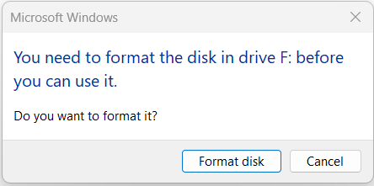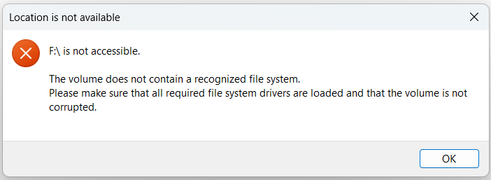
- Damaged Cards:
- Replace SD cards that show signs of physical damage or fail repeated tests.
- Use only high-quality, Class 10 SD cards (Extreme or Extreme Pro from SanDisk) as recommended by Wildlife Acoustics.

Battery Problems
- Battery Life Issues:
- Use fully charged or fresh batteries for every deployment.
- Avoid mixing old and new batteries.
- Extreme Weather Impact:
- In cold weather, only use ARUs with lithium-ion batteries for better performance.
- Check for excessive power drain if deployments occur in high heat or humidity.

Additional Tips
- Microphone Interference:
- Remove dirt, bird poop, or obstructions from the microphone using a soft cloth.
- Replace the windscreen if damaged.
- Configuration Errors:
- Double-check recording schedules, gain settings, and start/stop times before deployment.
- Re-upload configuration files if the device shows unexpected behavior.
- Firmware Updates:
- Check for and install the latest firmware updates from Wildlife Acoustics.
- Outdated firmware can cause device malfunctions or reduced performance.

11. Important ARU Care Instructions
Always handle the ARUs with care. They contain sensitive electronic components that will not withstand crushing or heavy impacts.
- Transport:
  - Dropping the units or having them bounce around during transport can cause damage to the connections inside and destroy the outside as well. In the field, always transport the ARUs with care and ensure they are in a dry bag or an otherwise dry environment.
  - The ARU microphones are sensitive to impact and pressure. If microphones are wet when you pick up a recorder, make sure to dry them out before storing the unit.
- Rain and snow events: Extra care is required when handling ARUs in wet weather and wet locations (e.g., marshes!!). When these units are closed, they are watertight and can withstand most weather conditions. However, do not get water onto the electronic components inside. Water will short out the electrical circuits and may cause permanent damage to the units. Take extra care when activating or deactivating units. The following steps may be used to minimize the amount of time the ARU is open if you need to deploy in precipitation.
  - Rainy day activation:
    - Set up ARUs in the truck or office: Load SD cards (if necessary), check batteries, pre-program configurations, and the recording prefixes.
    - Record the unit number, SD card number, and other information in the datasheet ahead of time so that a minimum amount of time is spent with the unit open in wet conditions.
    - In the field, minimize the time units are exposed to the elements.
    - Use a dry bag as a rain cover while having the unit open.
    - Store all materials in dry bags (SD cards, batteries, etc.) when transporting and not in a dry environment (e.g., truck or office).
- Mounting Consideration (SwiftOne users):
While this manual primarily references Wildlife Acoustics ARUs, SwiftOne users should avoid using power drills when securing mounting screws. Anecdotal evidence suggests that power tools can damage the hardware or warp the rubber gaskets, increasing the risk of water intrusion. Hand-screwing is strongly recommended to preserve the unit’s waterproof integrity.

12. Contribution
I welcome feedback and contributions to improve this manual. If you notice an error, outdated information, or have a suggestion, follow the steps below to submit your changes through GitHub.

How to Contribute Edits or Corrections
- Navigate to the Repository
Go to the GitHub repository where this manual is maintained.
https://github.com/kellyfaller/Coastal-Marsh-Acoustic-Monitoring-Analysis/
- Fork the Repository
  - Click the "Fork" button at the top right to create your own editable copy of the repository.
- Clone Your Fork to Your Computer (Optional)
  - Use GitHub Desktop or git clone to work locally.
  - Make sure your local files stay in the same folder structure for scripts to work.
- Create a New Branch
  - Name it something descriptive (e.g., typo-fix, update-spl-instructions, clarify-kaleidoscope).
- Make Your Edits
  - Open the .docx manual or relevant files from the /Docs/ folder.
  - Make your suggested edits (e.g., correcting typos, adding missing info).
  - Save your changes.
- Commit and Push
  - In GitHub Desktop (or your terminal), commit your changes with a clear message.
  - Push the changes to your forked repository on GitHub.
- Open a Pull Request
  - Navigate to your fork on GitHub and click "Compare & pull request".
  - Describe what you changed and why.
  - Submit the pull request for review.

Helpful Tips
- Edits to the manual should be made in the original .docx file located at:
Docs/Acoustic_Manual.docx
- For larger suggestions or questions, open an Issue in the GitHub repo to discuss first.
- Refer to the GitHub SOP for detailed screenshots and step-by-step help:
Docs/SOPs/GitHub_Desktop_SOP.docx

13. Appendices

Appendix A: Project-Specific Configuration Settings for Devices
This appendix provides example configuration settings for ARU devices, categorized by project. These settings should serve as a guideline and may need adjustments based on specific project goals. Always defer to the supervisor for final settings.

Project: 429 Low-Cost Low Tech

Project Goal: The 429 Low-Cost Low-Tech (LCLT) Project is a partnership between Ducks Unlimited, USFWS, Conserve Wildlife Foundation of New Jersey, and the Partnership for the Delaware Estuary to develop low-tech methods for salt marsh restoration that is scalable and effective. Acoustic monitoring is used for the project to develop methodologies for tracking faunal changes pre and post restoration. Some goals of the acoustic monitoring portion of the project include:
- Develop and refine deployment strategies for salt marsh acoustic data collection.
- Assess presence of rare species within the restoration AOI and track their presence over the course of the project.
- Calculate soundscape indices to evaluate their usefulness for tracking restoration success.
- Support conservation and restoration planning by integrating acoustic monitoring into ongoing assessments.

The configuration settings for this project were designed to capture the soundscapes during the breeding season of key salt marsh bird species, ensuring comprehensive acoustic data collection. The recording schedule was tailored to encompass critical vocalization periods, including the hours surrounding dawn and dusk (-2/+2 hours), which are known to be peak activity times for many marsh-dependent species.

Additionally, this schedule accommodates nocturnal species, such as the federally listed eastern black rail (Laterallus jamaicensis jamaicensis), which is known for its nighttime vocalizations. By including pre-dawn and post-dusk recording periods, we aimed to increase the likelihood of detecting this elusive species within its active vocalization window.
Below is the specific configuration settings used for the project:
- Configuration Name: “LCLT Deployment Configuration”
  - This pre-saved configuration is stored in the configuration library and is ready for immediate use. By using this configuration, you can avoid the need to manually input individual settings for each ARU during deployment.
  - Simply load the configuration onto the ARU through the Configuration App during deployments or ARU checks.
- Recording Schedule
  - Start Time: 2 hours before local sunrise.
  - End Time: 2 hours after local sunset.
  - Recording Pattern:
    - 30 minutes on, followed by 30 minutes off throughout the active schedule.
- Audio Settings
  - Sampling Rate: 44,100 Hz.
  - Gain:
    - Left Channel: 18 dB.
    - Right Channel: 18 dB.
  - Recording Mode: Highest Quality.
  - Channel: Stereo.
  - Maximum Recording Length: 2 minutes.
  - File Format
    - Recording Format: .wav This is the default.
- Location and Time Zones
  - Song Meter Mini:
    - Location and time zone settings are automatically configured via Bluetooth.
    - When connected to the Song Meter Configurator App, the Mini uses the location and time zone of the connected smartphone or tablet.
    - Tip: Ensure that the phone’s location services are turned on and that the correct time zone is selected before setting up the ARU.
  - SM4 Models:
    - Location and time zones must be manually configured in the device menu.
Project: 464 NJ Sea Grant
1. Configuration Name: “NJSG Configuration”
2. Recording Schedule
        - Start Time: Continuous
        - End Time: Continuous
        - Recording Pattern:
          - 10 minutes on, followed by 20 minutes off throughout the active schedule.
3. Audio Settings
              - Sampling Rate: 24,000 Hz
  - Gain:
    - Left Channel: 18 dB
    - Right Channel: 18 dB
c. Recording Mode: Highest Quality.
        - Channel: Stereo
        - Maximum Recording Length: 2 minutes
        - File Format: .wav This is the default.
- Location and Time Zones
  - Song Meter Mini:
    - Location and time zone settings are automatically configured via Bluetooth.
    - When connected to the Song Meter Configurator App, the Mini uses the location and time zone of the connected smartphone or tablet.
    - Tip: Ensure that the phone’s location services are turned on and that the correct time zone is selected before setting up the ARU.
  - SM4 Models:
    - Location and time zones must be manually configured in the device menu.

Appendix B: Field Packing Checklists

B.1: Deployment Checklist
ARUs and Power:
- Pre-configured ARUs with updated firmware
- Correct number of batteries per ARU:
  - SM4: 4 D-cell batteries
  - Song Meter Mini 1: 4 AA batteries
  - Song Meter Mini 2 AA: 8 AA batteries
  - Song Meter Mini 2 Lithium-Ion: 6 lithium-ion batteries
- Extra batteries (for replacements)
SD Cards:
- 1–2 formatted, labeled SD cards per ARU (128–256 GB, Class 10 or better) in a dry case
- Spare SD cards
Mounting Equipment:
- PVC, metal, or wooden stakes
- Mallet or hammer
- Zip ties (lots!)
- Zip tie tensioners
- Wire cutters or scissors
- Security brackets or fasteners
Field Documentation:
- Datasheets (deployment)
- Clipboard
- Pens and pencils
- GPS-enabled phone or GPS unit
- Camera or phone (for photos)
- Dry bags
Personal Gear:
- Weather-appropriate clothing
- Water and snacks
- Safety gear (e.g., waders, gloves, sun protection)

B.2: Mid-Season Maintenance Checklist
Replacement Items:
- Fresh batteries (as per model)
- Fresh formatted SD cards
- Spare windscreens
- Zip ties and extra mounting hardware
Inspection and Cleaning Tools:
- Nitrile gloves
- Cleaning wipes/alcohol pads
- Small brush or microfiber cloth
- Ammonia wipes (for raccoon deterrence)
- Ant gel bait or other insect deterrent
Documentation:
- Maintenance datasheets
- Clipboard, pens/pencils
- Camera or phone for photo documentation
Other Reminders:
- Test ARU audio before leaving the field
- Record observations on wildlife interference or damage

B.3: Retrieval Checklist
Tools and Equipment:
- Wire cutters/scissors
- Clipboard and retrieval datasheets
- Dry bags
- SD card holder or envelopes
Reminders:
- Stop the ARU schedule before powering off
- Eject and label SD cards (after powering off!)
- Disassemble mounting equipment
- Clean ARUs if visibly dirty
- Take photos of the site and ARU from all directions
- Fill out all the datasheet fields
- Confirm all gear has been collected

